**Maven Power LEGO Challenge**

**Objective:**

The dataset encompasses LEGO sets released from 1970 to 2022, providing information on each set's theme, pieces, recommended age, retail price, and image. The primary objectives of the challenge are to conduct an Exploratory Data Analysis (EDA) to unveil prevalent trends and perform a descriptive analysis of LEGO sets over a five-decade time period.

**Data:**

Dataset contains LEGO sets released from 1970 to 2022.

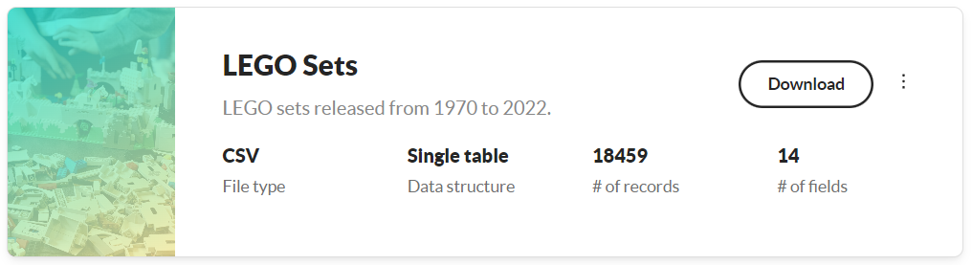

**Overview:**

Based in Billund, Denmark, The LEGO Group is a Danish company that produces construction toys. It produces toys under the Lego brand, most of which are made of interlocking plastic bricks. The LEGO Group also owns and runs a large number of retail establishments in addition to creating multiple Legoland amusement parks across the globe.

**Analysis:**

This report caters to LEGO enthusiasts spanning the years 1970 to 2022, encompassing diverse age ranges. It comprises three key sections: Overview, Sets/Pieces, and Trend Analysis. For in-depth insights, hover over visuals or utilize dropdowns.

Commencing the Exploratory Data Analysis (EDA), minimal data cleaning was needed, involving only column format adjustments and numerous DAX queries to finalize the analysis for LEGO Sets over time. Transitioning to the overview page, it presents a comprehensive statistical analysis spanning 53 years of LEGO's evolution, showcasing a remarkable 2317.50% increase over the years. The page features six main numbers illustrating the overall distribution of LEGO sets, accompanied by key insights derived from these numbers.

The Sets/Piece page provides a detailed breakdown of LEGO sets, including themes, pieces, the total number of pieces produced over the years, and a customizable view section for exploring patterns of interest. Additionally, it highlights the age distribution with the highest number of LEGO sets.

On the Trend Analysis page, you'll find insights into the main trends and patterns over the years, covering pieces, retail prices, themes, subthemes, and their transformations. This page captures the key trends and their evolution over time.

**Key Insights:**

Some of the key findings from the analysis include:

* LEGO sets exhibited a remarkable 2317.50% increase from 1970 to 2022, peaking at 967 sets in 2022, closely followed by 2021 and 2017.
* Enduring themes across five decades include Bricklink, Power Functions, Powerd Up, Agents, and Ben 10.
* Overall production volume saw a significant 1119.29% increase, with the World Map set boasting over 11.6k pieces.
* The year 2022 led with 279k pieces, marking a 7,447.14% increase from 1970's lowest at 3706 pieces.
* 63.23% of LEGO sets have no age limit, surpassing age-restricted sets by 13.23%.
* Retail price records emerged post-1990, with the Millennium Falcon reaching $850 and the World set priced at $250 with a record 11.6k pieces.
* Despite seven categories remaining constant, themes and subthemes evolved positively, correlating with growth percentages over the five decades.

**Design/Theme:**

I've created custom backgrounds for both light and dark themes using Figma. The colors were carefully chosen from LEGO set images and fine-tuned at coolors.io to ensure a perfect match for each theme. This selected color palette is consistently applied across all visualizations.